**Building Business Model – STUDY TUTOR**

**Business Model :**

Our business model is to create a Study Tutor platform that provides an all-in-one solution for students to learn and prepare for their studies using artificial intelligence. The platform will offer various features that help students in their studies, such as analogy maker, factual answering, summarizing, essay writing, note-taking, and more.

Our target audience is students of all ages who want to improve their academic performance and reduce their study time. We aim to create a seamless user experience that allows students to interact with our AI-powered tools easily.

**Selected Use Cases :**

1. **EXTRACT** **KEYWORDS**: This use case was chosen because it can help users quickly extract contact information from a large set of text. This use case can be developed by using natural language processing algorithms that can identify patterns in text that indicate contact information. End-users can input the text they want to extract contact information from, and the system will provide a list of contact information that it has extracted.

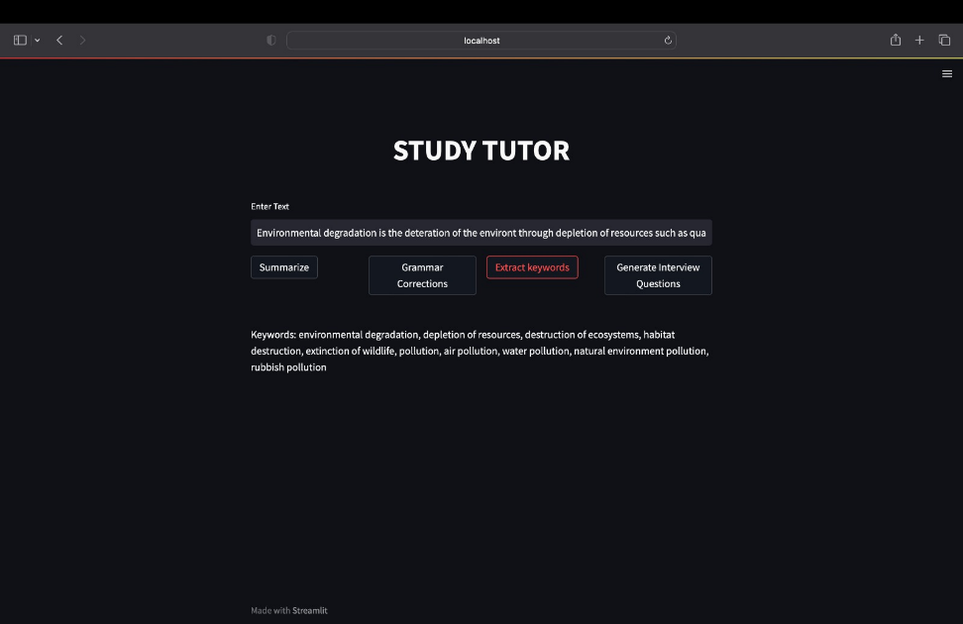

1. **SUMMARIZE FOR A 2nd GRADER** : This feature helps students make the complex text easier to understand by summarizing it into simpler. This feature can be useful for students who struggle with reading comprehension or for anyone who wants to quickly grasp the main idea of a piece of text.

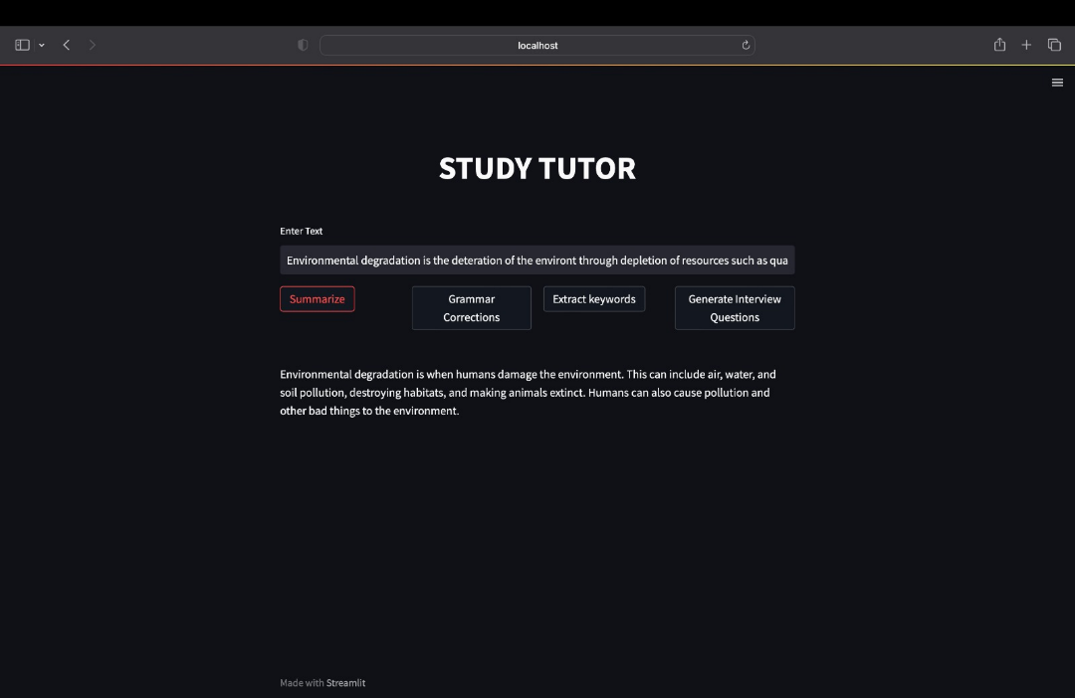

1. **GRAMMAR CORRECTION** : Students can use this feature to automatically correct grammar mistakes in their essays or articles. This feature will use natural language processing technology to analyze the text and suggest corrections.

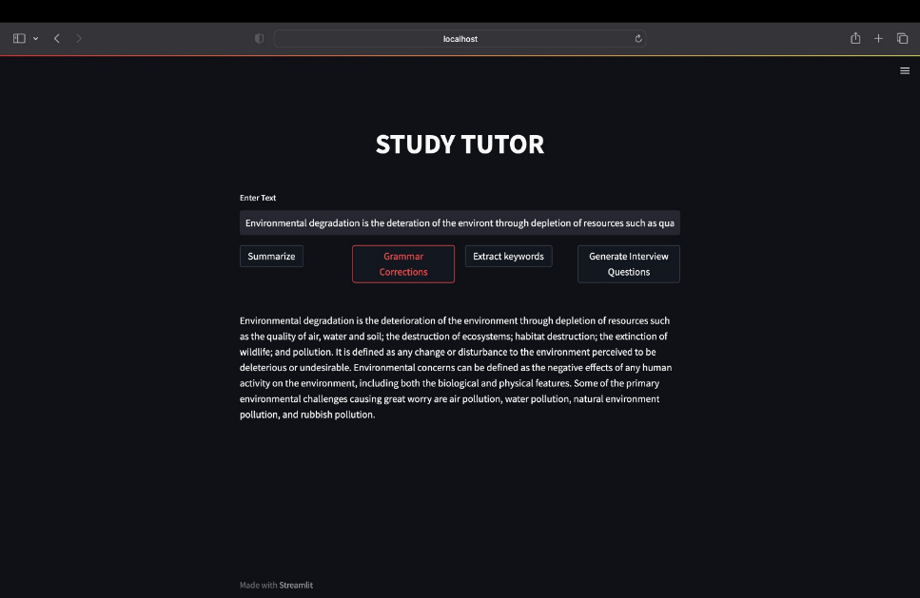

1. **INTERVIEW QUESTIONS** : Students can use this feature to generate interview questions for their research projects or job interviews automatically. This feature will use machine learning technology to identify the most relevant questions based on the input text.

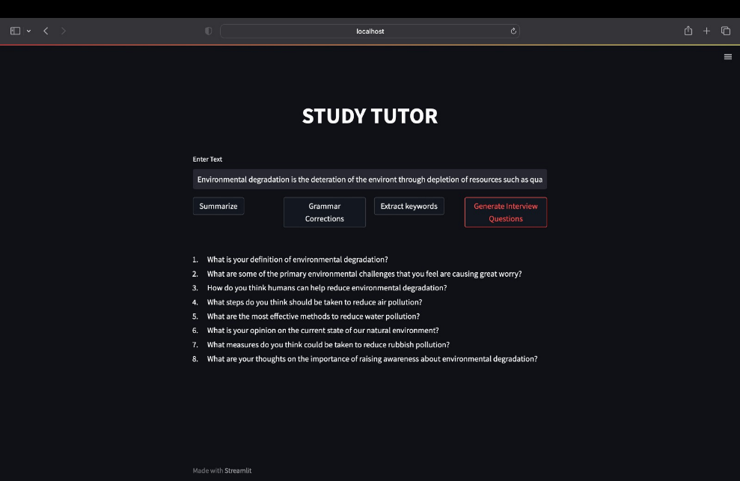

**Additional Use Cases:**

1. **ANALOGY MAKER** : This helps users understand complex concepts by using analogies. This use case can be developed by using machine learning models that can generate analogies based on input concepts. End-users can input the concept they want to understand better, and the system will provide an analogy that makes the concept easier to understand.
2. **NOTES TO SUMMARY** : This helps users quickly review the key points of their notes. This use case can be developed by using natural language processing algorithms that can identify the most important points in a set of notes. End-users can input their notes, and the system will provide a summary that highlights the most important points.
3. **ESSAY OUTLINE** : This use case helps users organize their thoughts and ideas before writing an essay. This use case can be developed by using natural language processing algorithms that can identify the most important points in a set of notes and then generate an outline based on those points. End-users can input their notes, and the system will provide an outline that can serve as a guide for writing the essay.
4. **CREATE STUDY NOTES** : Students can use this feature to create study notes for their exams automatically. This feature will use machine learning technology to identify the key points and generate relevant study notes.
5. **CHAT** : Students can use this feature to interact with an AI-powered chatbot that can answer their questions and provide study tips. This feature will use natural language processing technology to understand the user's questions and provide relevant responses.
6. **TL;DR SUMMARIZATION** : Students can use this feature to summarize long articles or textbooks into shorter, more manageable summaries. This feature will use machine learning technology to identify the key points and summarize them in a concise manner.
7. **FACTUAL ANSWERING** : Students can ask factual questions related to their studies and receive accurate answers. This feature will use natural language processing technology to understand the question and search for the answer in a database of factual information.
8. **ENGLISH TO OTHER LANGUAGES** : Students who are non-native English speakers can use the platform to translate English text into their preferred language. This feature will use machine translation technology to provide accurate translations.

Top of Form

Bottom of Form